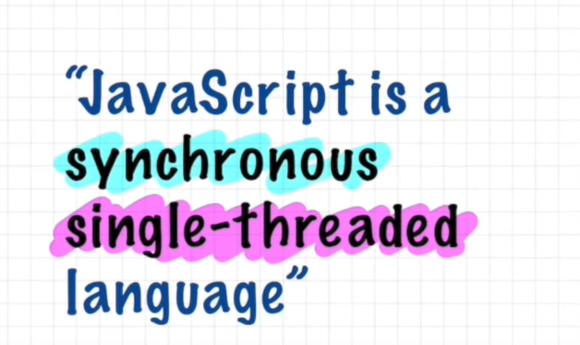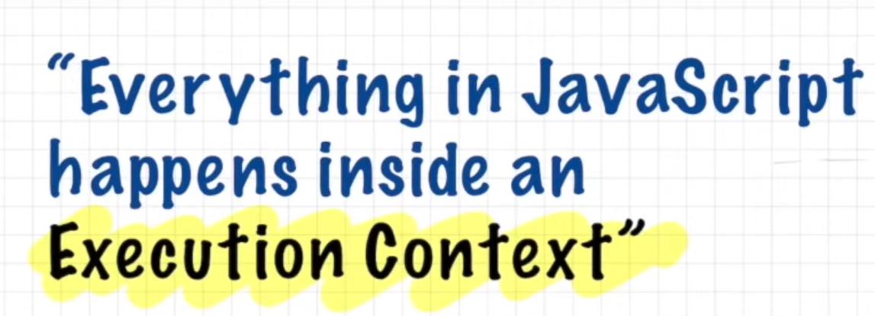

* You can assume this execution context to be a big box or a container in which whole javaScript code is executed
* It has two component in it :
* The first component is known as the memory component.
* This is the place where all the variable and functions are stored as key value pairs
* Memory component is also known as variable environment
* The second component of this execution context is the code component.this is the place where code is executed one line at a time
* It is also known as Thread of execution.
* Thread of execution is like a thread in which the whole code is executed one line at a time
* Single threaded:means javaScript can only execute one command at a time
* Synchronous single threaded: that means javaScript can only execute one command at a time and in a specific order
* That means It can only go to the next line once the current line has been finished executing.